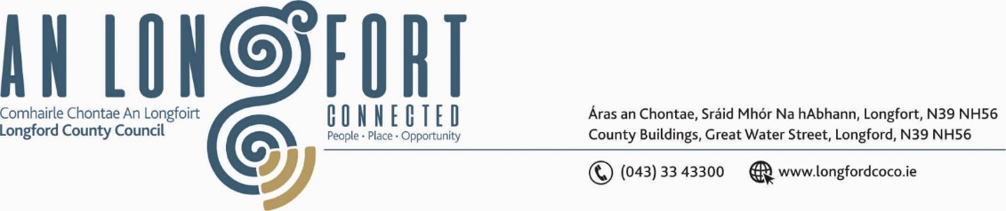

***BALLYMAHON MUNICIPAL DISTRICT***

***Please note meeting will be held via Microsoft Teams.***

**20 January 2022.**

**To: Each Member of Ballymahon Municipal District.**

**Dear Member,**

You are requested to attend a Meeting of Ballymahon Municipal District to be held

**via Microsoft Teams** on **Thursday 27 January 2022 at 4pm** to transact business, as set out on the Agenda hereunder.

**Yours sincerely**,

Ann Marie Mc Keon

_______________

**Ann Marie Mc Keon,**

**Meetings Administrator.**

**AGENDA**

Prayer before meeting.

**1.** Confirmation of Minutes of Ballymahon Municipal District Meeting held on

the 25 November – copy enclosed.

**2.** Matters arising from Minutes.

**3.** Declaration of Interest by Members.

**4.** Management Report - enclosed.

**5.** Presentation on Age Friendly Healthy Homes Programme.

**6.** Ardagh Clock Tower**.**

**7.** Proposed Projects/Expression of interest.

**8**. Consideration and adoption of Draft Municipal District Report for inclusion in

Longford County Council 2021 Annual Report – enclosed.

**9.** Consideration of one Nominee for each of the 2020/2021 and 2021/2022 Cathaoirleach Awards.

**10.** Community Grant Support Scheme 2022.

**11. Notices of Motions, submitted by Councillors, as listed hereunder –**

**Councillor Paul Ross**

(i) “I call on Longford County Council to extend the footpath on the Creevaghbeg Road to include the number of houses which are in close proximity of the existing path along the road”.

(ii) “I call on Longford County Council to upgrade the windows in the houses at Foxhall Crescent, Legan, as they are in very poor condition and are badly in need of replacement”.

(iii) “I call on Longford County Council to carry out a review of the Playground in Ballymahon in relation to maintenance and location, as this playground is often littered with bottles and used for anti-social behaviour and is generally in poor condition”.

**Councillor Pat O’Toole**

(i) “I call on Longford County Council to provide public lighting at the Kayak Club carpark on the Thomond Road Ballymahon.”

(ii) “I call on Longford County Council to include local road L1131 Rathmore to Shrule in the next speed limit review of our roads network with a view to reducing the limit on this road to the lowest permissible”.